Part 1 - Data Analysis and Management using Hadoop & Hive
Project Title - Financial Forecasting Frontier: Distributed Machine Learning for Banking Analytics

Objective
The objective of this part is to demonstrate how distributed storage and querying technologies can be used to efficiently manage large-scale banking datasets. Hadoop provides a distributed storage architecture, while Hive enables SQL-like querying on large datasets stored across a distributed environment. Using Apache Spark with Hive support, the banking dataset is loaded, stored, and queried to generate meaningful business insights.

Problem Statement
Modern banks generate enormous volumes of customer data every day, including customer demographics, account balances, loan information, marketing campaign records, and transaction histories. Processing such datasets using traditional single-machine systems becomes increasingly inefficient due to limitations in memory, processing speed, and scalability.
Distributed computing technologies overcome these limitations by distributing storage and computation across multiple nodes. In this project, Hadoop and Hive are used to simulate a scalable data management environment for banking data.

Dataset Description
The project uses the bank.csv dataset containing customer information used for direct marketing campaigns.
Important attributes include:
- Age
- Job
- Marital Status
- Education
- Account Balance
- Housing Loan
- Personal Loan
- Contact Type
- Campaign Information
- Previous Marketing Outcome
- Target Variable (Subscription to Term Deposit)
These attributes help analyse customer behaviour and predict subscription outcomes.

Technologies Used
- Apache Hadoop (Distributed Storage Concept)
- Apache Hive
- Apache Spark
- Spark SQL
- PySpark
- Python

Hadoop and Hive Architecture
The overall workflow implemented in this project is:
- Load the banking dataset.
- Initialize a Spark Session with Hive support enabled.
- Register the dataset as a Hive-managed table.
- Execute SQL queries using Spark SQL/HiveQL.
- Store metadata inside the Hive metastore.
- Generate analytical insights for business decision making.
This architecture separates storage from computation and allows scalable querying of structured banking data.

Implementation
Step 1: Creating Spark Session with Hive Support
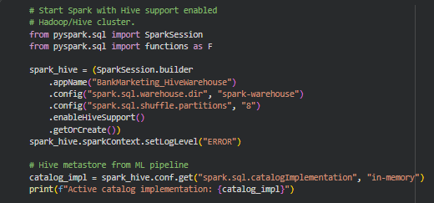
A Spark Session was created with Hive support enabled. This allows Spark to communicate with the Hive metastore and execute HiveQL queries on distributed datasets.
Example operations include:
- Creating SparkSession
- Enabling Hive support
- Initializing SQL execution engine

Step 2: Loading Banking Dataset
The bank marketing dataset is loaded into a Spark DataFrame.
The DataFrame automatically distributes data across Spark partitions, allowing parallel processing instead of loading the complete dataset into local memory.

Step 3: Creating Hive Table
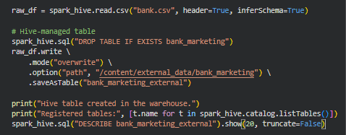
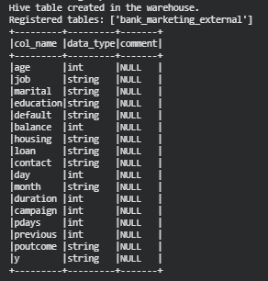
The Spark DataFrame is stored as a Hive-managed table.
This enables:
- Permanent metadata storage
- SQL querying
- Easy retrieval
- Better data organization

Step 4: Querying Using HiveQL / Spark SQL
Several SQL queries are executed on the Hive table to analyse banking data.
Examples include:
- Counting total customers
- Distribution of customers by job
- Average account balance
- Customers having housing loans
- Subscription statistics
- Campaign performance analysis
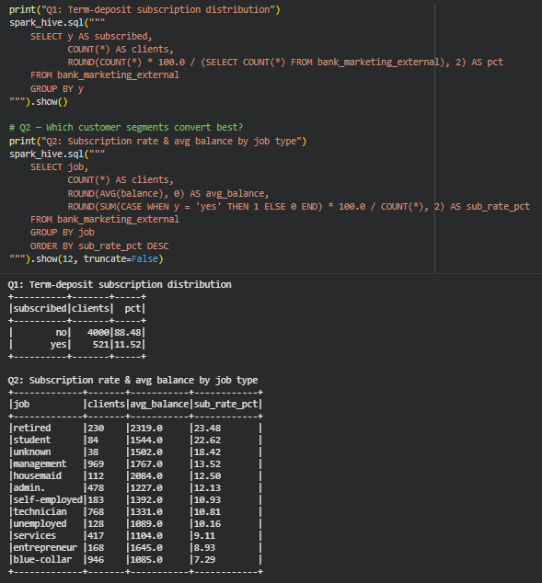
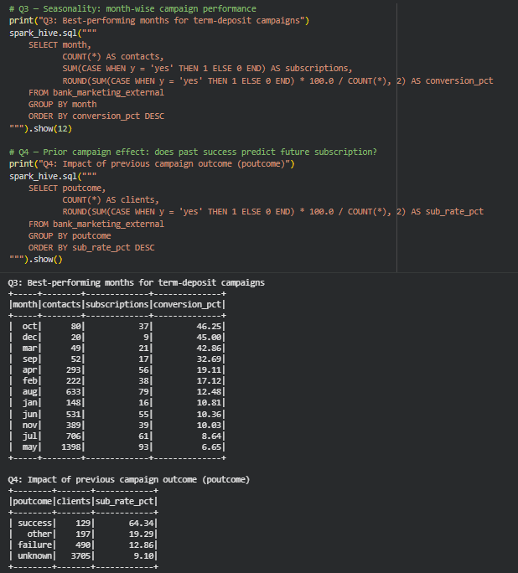
Using SQL allows analysts to retrieve insights efficiently without writing complex data-processing code.

Business Insights Obtained
The Hive queries help identify important trends within the banking dataset.
Some key observations include:
- Customer occupations significantly influence subscription rates.
- Housing loan status affects marketing outcomes.
- Customers with successful previous campaign outcomes are more likely to subscribe.
- Average account balance varies across different customer groups.
- Campaign effectiveness differs based on customer demographics.
These insights can assist banks in designing targeted marketing campaigns and improving customer acquisition strategies.

Advantages of Hadoop & Hive
Using Hadoop and Hive provides several benefits over traditional data processing.
- Scalable storage for large datasets.
- Distributed execution across multiple nodes.
- Faster SQL-based analytics.
- Efficient handling of structured banking data.
- Integration with Spark for advanced analytics and machine learning.
- Reduced processing time for large-scale workloads.

Challenges Faced
During implementation, several challenges were encountered:
- Managing a single active Spark session while enabling Hive support.
- Configuring Hive metastore correctly.
- Understanding the interaction between Spark SQL and HiveQL.
- Avoiding unnecessary conversion of distributed DataFrames into local Pandas DataFrames.
- Ensuring compatibility between Spark and Hive components.

Learning Outcomes
This section helped in understanding how distributed storage systems are used in real-world banking applications.
Key learnings include:
- Difference between local storage and distributed storage.
- Working with Hive-managed tables.
- Executing SQL queries using Spark SQL.
- Managing structured banking data in a distributed environment.
- Understanding how Hadoop and Hive form the foundation for large-scale analytics before machine learning and streaming are applied.

Conclusion
The Hadoop and Hive implementation successfully demonstrated how distributed technologies can manage and query large-scale banking datasets efficiently. By integrating Hive with Apache Spark, structured banking data can be queried using SQL while benefiting from distributed execution. This provides a scalable foundation for exploratory data analysis, machine learning, and real-time analytics performed in later stages of the project.

